Automatic Attendance System

Introduction

An automatic attendance system is a valuable solution that addresses several challenges associated with manual attendance tracking. One of the primary benefits is the significant improvement in time efficiency. Traditional manual processes, particularly in large classrooms or organizations, can be laborious and time-consuming. By automating the attendance tracking process, both students and instructors can save valuable time that can be better utilized for educational activities.

In addition to time efficiency, an automatic attendance system helps reduce the administrative burden associated with manual record-keeping. Administrative staff often face challenges in manually recording attendance and maintaining accurate records. Automation streamlines these tasks, allowing staff to focus on more critical aspects of their roles.

Real-time tracking is a crucial advantage of automatic attendance systems. Unlike manual processes that require additional time for data entry and processing, automated systems provide instant and up-to-date attendance information. This real-time tracking benefits instructors, administrators, and students, fostering a more dynamic and responsive learning environment.

In conclusion, the adoption of automatic attendance systems represents a significant step forward in improving efficiency, accuracy, and security in attendance tracking processes across diverse educational and organizational environments.

Features

The attendance system boasts a range of features that collectively contribute to its efficiency and user-friendliness. One of its standout capabilities is the implementation of advanced face recognition technology. This enables the system to dynamically identify and recognize individuals from group photos, providing a modern and accurate method for attendance tracking.

Users can upload multiple group photos in a single session, showcasing the system's flexibility in handling various scenarios. Each image is processed independently, ensuring comprehensive attendance tracking for diverse situations. This feature not only saves time as we take 3 photos of the class in day.

Real-time attendance tracking is a key aspect of the system's functionality. As images are processed, attendance records are instantly updated, providing users with immediate insights into participant presence. This real-time feature enhances the system's responsiveness and usability, particularly in dynamic environments.

Automatic CSV file generation is a notable feature that simplifies record-keeping and analysis. Once images are processed, the system automatically generates a CSV file containing detailed attendance records, including roll numbers and attendance status. This file serves as a convenient and accessible format for further data manipulation or archival purposes.

To enhance user convenience, the system offers downloadable attendance reports. Users have the option to download the generated CSV file, facilitating seamless integration with external tools or record-keeping systems. This feature adds flexibility to how users can utilize and share attendance data.

Technology Stack

The technology stack for this project is built on a robust combination of Python, HTML, CSS, JavaScript, and the Django web framework. Python, a versatile and widely-used programming language, serves as the backend language for implementing server-side logic. Django, a high-level Python web framework, provides a structured and efficient development environment, streamlining the creation of web applications. It incorporates a powerful Object-Relational Mapping (ORM) system for database interactions and follows the Model-View-Controller (MVC) architectural pattern.

For the frontend, HTML, CSS, and JavaScript collectively form the technology stack. HTML defines the structure of the web pages, CSS handles the styling and layout, and JavaScript enhances the user interface with dynamic and interactive elements. This frontend technology trio ensures a visually appealing and responsive user experience.

The project leverages the Django framework's built-in templating engine, which seamlessly integrates Python code into HTML templates. This simplifies the rendering of dynamic content on the frontend, ensuring a cohesive connection between the backend logic and the user interface.

In addition to the core technologies, the project employs various tools and libraries to enhance the development process. This includes version control with Git for collaborative coding, an Integrated Development Environment (IDE) such as Visual Studio Code for efficient coding, and Django's built-in development server for testing during the development phase.

In conjunction with the primary technology stack, this project incorporates specific Python modules and libraries to address facial recognition and data serialization. The face-recognition library, a powerful and user-friendly tool, is utilized for facial detection and recognition within images. Leveraging this library, the application can identify faces in group photos, compare them against reference face encodings, and accurately mark attendance.

The project also employs the pickle module, a standard Python library, for efficient and seamless serialization of Python objects. In this context, pickle is utilized to store and retrieve facial encodings associated with registered students. By saving these encodings to a file, the application ensures persistent storage of reference data, enabling quick and reliable comparisons during the attendance tracking process.

Furthermore, the os module is integrated to facilitate interaction with the operating system. It is particularly instrumental in managing file paths, allowing the application to locate and access necessary files such as the pickled reference face encodings. This module enhances the project's flexibility and portability across different environments.

Implementation

The implementation of the automatic attendance system centers around the utilization of facial recognition technology and a systematic approach to data handling. Leveraging the face-recognition library, the system systematically processes group photos submitted by users, identifying and comparing faces against a reference set. This comparison is achieved by calculating the minimum distance between the facial encodings of individuals in the group photo and those stored as reference data.

A key aspect of the implementation involves the use of a dictionary **data structure** to manage and update attendance status dynamically. Each student's roll number serves as a key, with the corresponding value representing their attendance status (either "Present" or "Absent"). This dictionary structure efficiently captures and organizes attendance information for all individuals in the specified roll number range.

As the system iterates through the facial encodings of the group photo, it calculates the distance between each face and the reference faces stored in the pickled file. The minimum distance is then identified, and the associated roll number is marked as "Present" in the attendance dictionary. This systematic comparison ensures accurate attendance tracking, utilizing the inherent uniqueness of facial features.

Furthermore, the use of the CSV (Comma-Separated Values) file format for recording attendance results enhances accessibility and compatibility. The system creates a CSV file containing the roll numbers and their corresponding attendance statuses, allowing users to conveniently download and review the attendance data.

The implementation also incorporates error handling mechanisms to skip specific roll numbers that may not be present in the reference set or face recognition errors. This ensures the robustness and reliability of the system under various scenarios.

In summary, the implementation of the automatic attendance system is characterized by the systematic use of facial recognition technology, the dynamic management of attendance data through a dictionary, and the efficient generation of downloadable CSV files. These components collectively contribute to the accuracy, accessibility, and user-friendliness of the attendance tracking process.

Results

Our model gave pretty accurate results, You can view the accuracy matched my the following images:

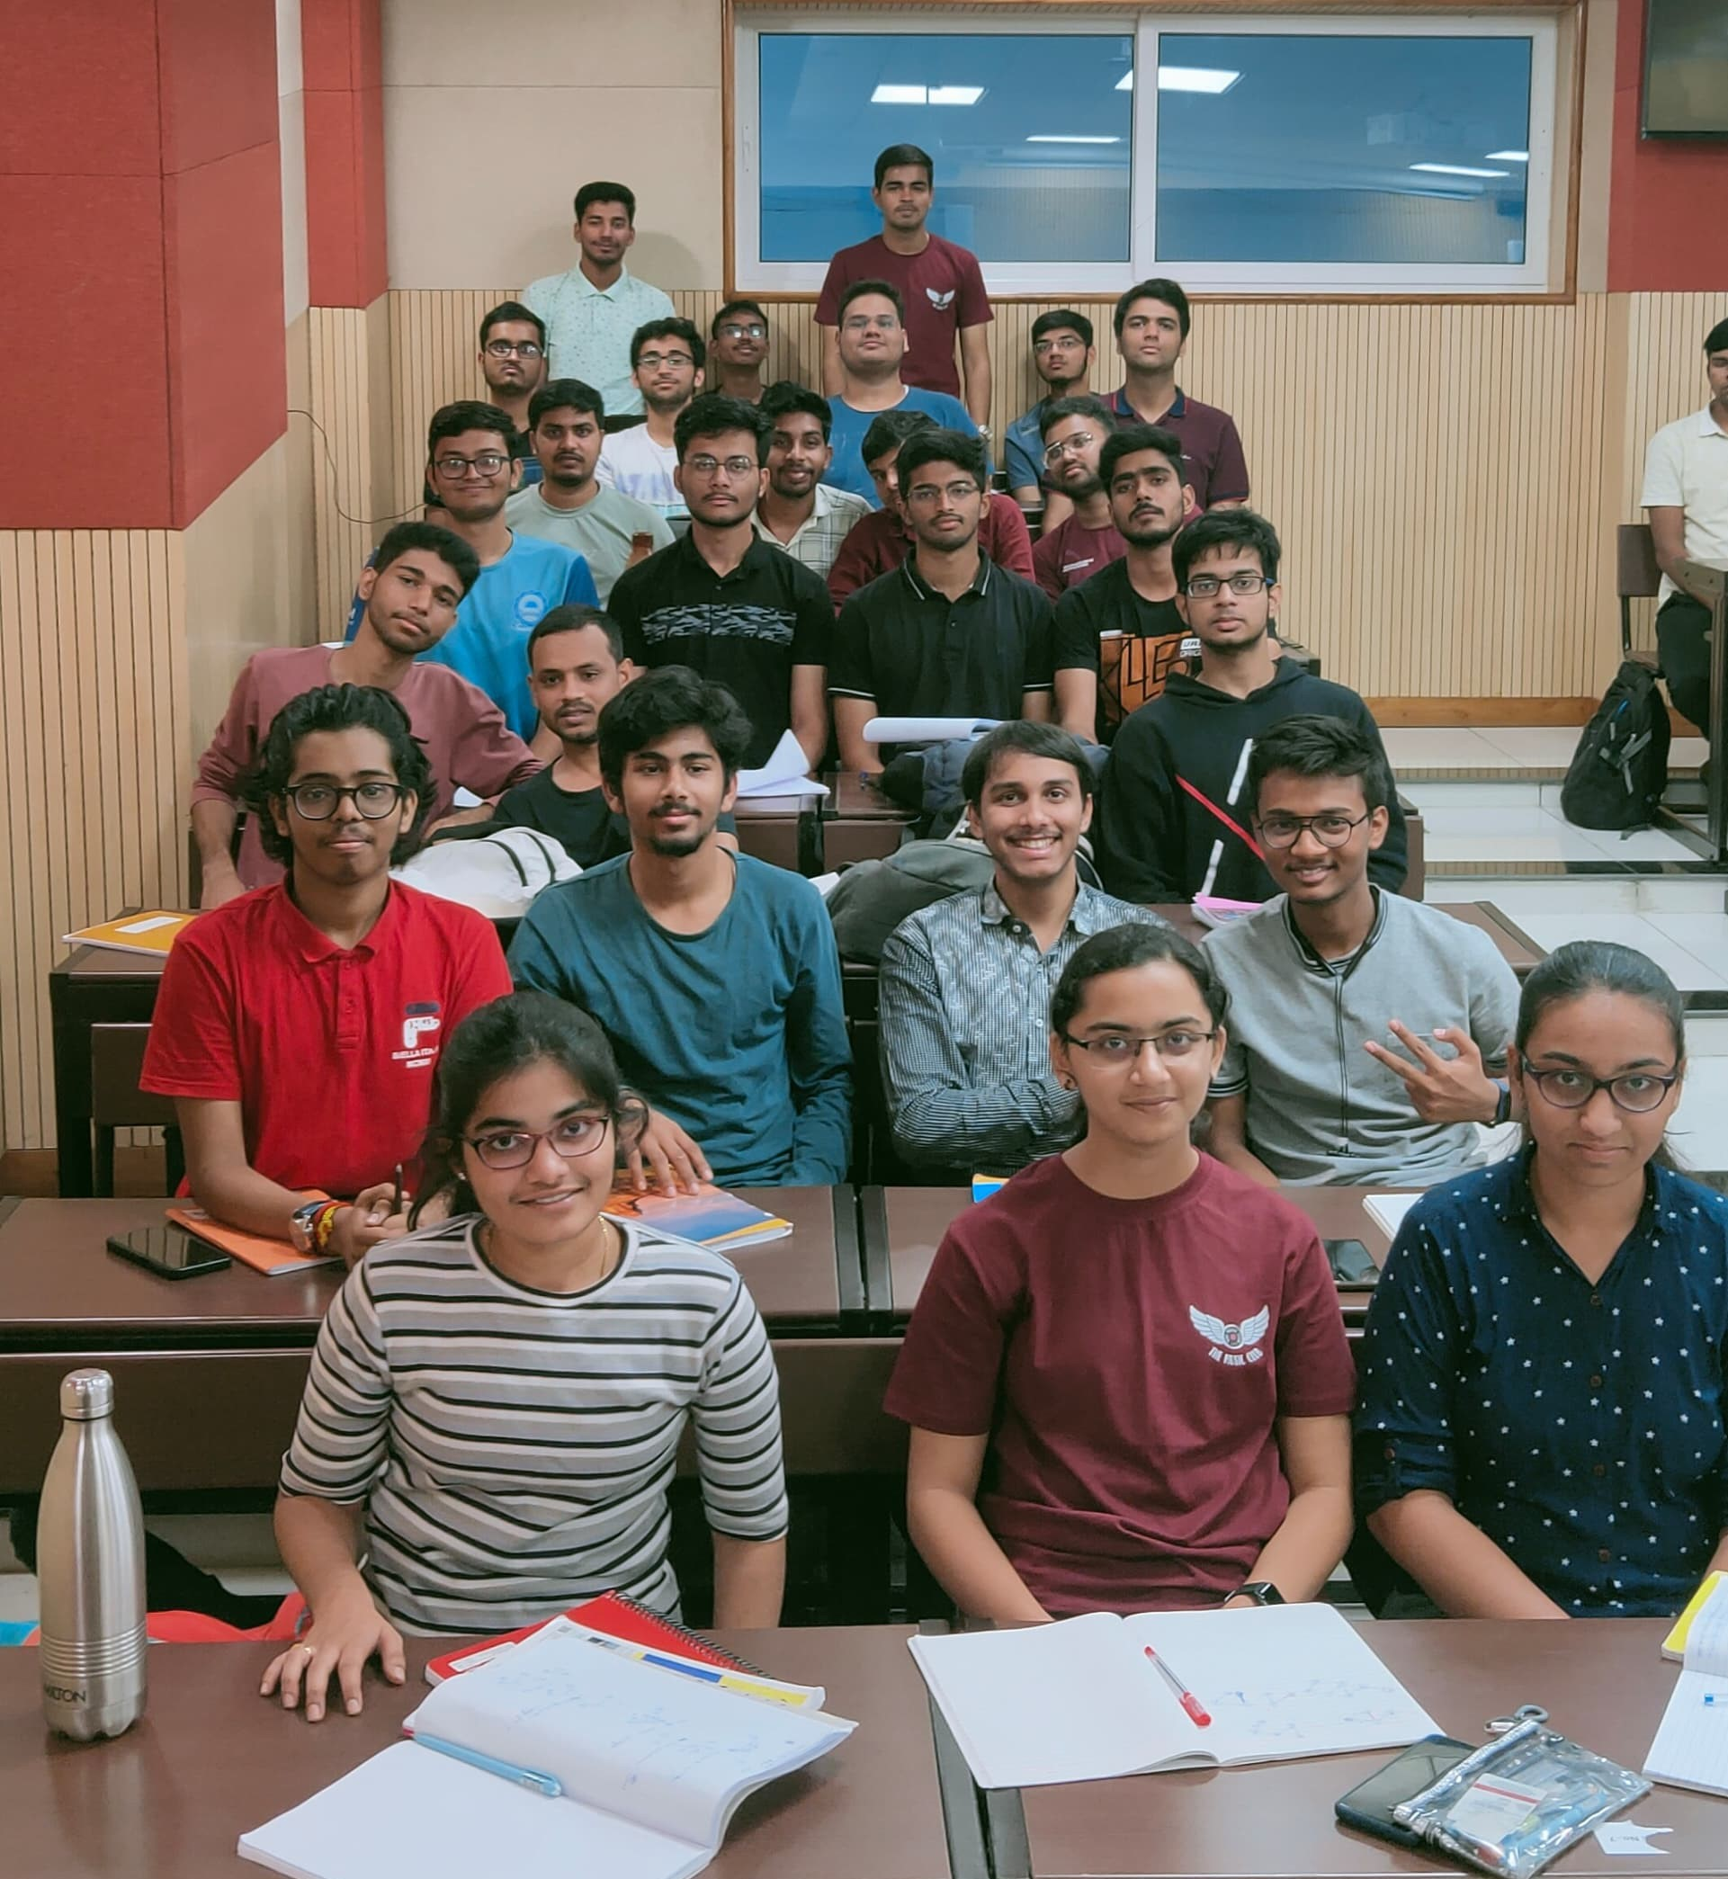

Both these images gave 90+ accuracy which shows that our project is working pretty good.

Conclusion

In conclusion, the automatic attendance system leveraging facial recognition technology presents an innovative and efficient solution for tracking attendance in group settings. The implementation, grounded in the robust face-recognition library and dynamic data structures, ensures accuracy and reliability in identifying individuals. The use of a dictionary facilitates real-time updating of attendance statuses, while the CSV file output enhances accessibility and user convenience.